Mujtaba Shahid Faizi

BSCS-5A

#131818

Lab 9 of DIP

**Task 1:  
Code:**

**import** numpy **as** np  
**import** cv2  
  
img = cv2.imread(**'laracroft.png'**,0)  
kernel = np.ones((5,5), np.uint8)  
  
img_erosion = cv2.erode(img, kernel, iterations=1)  
img_dilation = cv2.dilate(img, kernel, iterations=1)  
opening = cv2.morphologyEx(img, cv2.MORPH_OPEN, kernel)  
closing = cv2.morphologyEx(img, cv2.MORPH_CLOSE, kernel)  
  
cv2.imshow(**'Erosion'**, img_erosion)  
cv2.imshow(**'Dilation'**, img_dilation)  
cv2.imshow(**'Opening'**, opening)  
cv2.imshow(**'Closing'**, closing)  
cv2.waitKey(0)  
cv2.destroyAllWindows()

**Screenshot:**



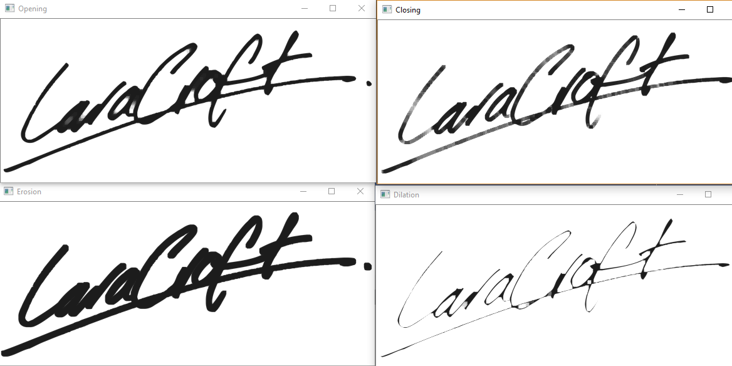

Dilation has shrunk the foreground image while erosion has expanded it. Opening has filled small holes and joined some parts, while vice versa for closing.

**Task 2:  
Code:**

**import** numpy **as** np  
**import** cv2  
  
img = cv2.imread(**'Task2.png'**,0)  
kernel = np.ones((5,5), np.uint8)  
ret,thresh_img = cv2.threshold(img,50,255,cv2.THRESH_BINARY_INV)  
img_erosion = cv2.erode(thresh_img, kernel, iterations=1)  
img_dilation = cv2.dilate(thresh_img, kernel, iterations=1)  
cv2.imshow(**"dd"**,img_dilation)  
cv2.waitKey(0)  
cv2.destroyAllWindows()

**Screenshot:**

The image was already 2D, so there was no difficulty in segmentation.

